Index

|  |  |  |
| --- | --- | --- |
| **Sr. No.** | **Contents** | **Page No.** |
| **1** | **Annexure I– Micro Project Proposal** | **1-2** |
| 1.Aims/Benefits of the Micro-Project | 1 |
| 2. Course Outcome Addressed | 1 |
| 3.Proposed Methodology | 1 |
| 4. Action Plan | 2 |
| 5. Resources Required | 2 |
| 6. Name of Team Members with Roll No.’s | 2 |
| **2** | **Annexure II – Micro Project Report** | **3-8** |
| 1.Rationale | 3 |
| 2.Aims/Benefits of the Micro-Project | 3 |
| 3.Course Outcome Achieved | 3 |
| 4. Literature Review | 3 |
| 5.Actual Methodology Followed | 4 |
| 5.1 Syntax | 5 |
| 5.2 Source code | 4-6 |
| 6.Actual Resources Used | 7 |
| 7.Outputs of Micro-Projects | 8 |
| 8. Skill developed / Learning out of this Micro-Project | 8 |
| 9. Applications of this Micro-Project | 8 |

## Annexure I

**Micro Project Proposal**

# TRIGGERS

## Aims/Benefits of the Micro-Project:

* + Produce additional checking during insert, update or delete operations on the affected table.
  + They allow us to encode complex default values that cannot be handled by default constraints.
  + Implement referential integrity across databases. You can read more about this in this tip: [SQL Server Referential Integrity Across Databases Using Triggers](https://www.mssqltips.com/sqlservertip/5919/sql-server-referential-integrity-across-databases-using-triggers/).
  + They allow us to control what actually happens when one performs an insert, update, or delete on a view that accesses multiple tables.
  + You can calculate aggregated columns in a table using triggers

## Course Outcome Addressed:

* CO-1: Create and Manage Database using SQL Commands.
* CO-2: Apply triggers on database and also create the procedure.
* CO-3: Create function according to condition.

## Proposed Methodology:

A trigger is a stored procedure in database which automatically invokes whenever a special event in the database occurs. For example, a trigger can be invoked when a row is inserted into a specified table or when certain table columns are being updated.

## Action Plan:

|  |  |  |  |  |
| --- | --- | --- | --- | --- |
| **Sr.**  **No.** | **Details of Activity** | **Planned**  **Start date** | **Planned**  **Finish date** | **Name of Responsible**  **Team Members** |
| 1 | Search the information of  database | 14-09-2022  3:30 – 5:30 PM | 16-09-2022  3:30 – 5:30 PM | Akshay Dashrath Gitte |
| 2 | Collect the information of  trigger | 19-09-2022  3:30 – 5:30 PM | 23-09-2022  3:30 – 5:30 PM |
| 3 | Analysis of different  information | 26-09-2022  3:30 – 5:30 PM | 29-09-2022  3:30 – 5:30 PM |
| 4 | Analysis of information | 03-10-2022  3:30 – 5:30 PM | 06-10-2022  3:30 – 5:30 PM | Harsh Moreshwar  Kale  Sujit Sudhakar  Sukane |
| 5 | Compression of Database | 10-10-2022  3:30 – 5:30 PM | 13-10-2022  3:30 – 5:30 PM |
| 6 | Features of Database | 20-10-2022  3:30 – 5:30 PM | 01-11-2022  3:30 – 5:30 PM |
| 7 | Advantages and drawback  of trigger | 03-11-2022  3:30 – 5:30 PM | 07-11-2022  3:30 – 5:30 PM |
| 8 | Final report of project | 14-11-2022  3:30 – 5:30 PM | 17-11-2022  3:30 – 5:30 PM |

1. **Resources Required:**

|  |  |  |  |  |
| --- | --- | --- | --- | --- |
| **Sr. No**  **.** | **Name of resource / material** | **Specification** | **Quantity** | **Remarks** |
| 1 | Computer | WINDOWS 11,8GB  RAM | 1 |  |
| 2 | Operating System | WINDOWS 11 | 1 |  |
| 3 | Software | Oracle Database 10G | 1 |  |
| 4 | Browser | Google Chrome | 1 |  |

## Names of Team Members with Roll No.’s:

|  |  |  |  |
| --- | --- | --- | --- |
| **Sr.**  **No.** | **Enrollment No.** | **Name of Team Member** | **Roll No.** |
| 1 | 2110950049 | Akshay Dashrath Gitte | 01 |
| 2 | 2110950051 | Harsh Moreshwar Kale | 03 |
| 3 | 2110950159 | Sujit Sudhakar Sukane | 60 |

**Mr. Lokre A. P.**

## Name and Signature of the Teacher

**Annexure – II**

**Micro-Project Report**

# TRIGGERS

## Rationale:

The main purpose of triggers is to automate execution of code when an event occurs. In other words, if you need a certain piece of code to always be executed in response to an event, the best option is to use triggers. Mostly because they guarantee that the code will be executed or the event that fired the trigger will fail.

## Aims/Benefits of the Micro-Project:

* + Produce additional checking during insert, update or delete operations on the affected table.
  + They allow us to encode complex default values that cannot be handled by default constraints.
  + Implement referential integrity across databases. You can read more about this in this tip: [SQL Server Referential Integrity Across Databases Using Triggers](https://www.mssqltips.com/sqlservertip/5919/sql-server-referential-integrity-across-databases-using-triggers/).
  + They allow us to control what actually happens when one performs an insert, update, or delete on a view that accesses multiple tables.
  + You can calculate aggregated columns in a table using triggers

## Course Outcomes Achieved:

* + CO-1: Create and Manage Database using SQL Commands.
  + CO-2: Apply triggers on database and also create the procedure.
  + CO-3: Create function according to condition.

## Literature Review:

Triggers are stored programs,which are automatically executed or fired when some events occur.Triggers are in fact written to be executed in response to any of the following events

* + Create trigger before update

## Actual Methodology followed

* 1. **Syntax:**
* **Create trigger before update:-**

CREATE [ OR REPLACE ] TRIGGER *trigger_name*

BEFORE UPDATE

ON *table_name*

[ FOR EACH ROW ] DECLARE

-- variable declarations BEGIN

-- trigger code EXCEPTION

WHEN ...

-- exception handling END;

## Source Code:

* **Create trigger before update:-**

create or replace trigger first before update on Emp_t

for each row begin

insert into Emp_A values(:old.E_id;:old.Ename;:old.salary); end;

/

UPDATE employees

SET salary = salary + 1000.0 WHERE Department_id = 20;

## Actual Resources Used:

|  |  |  |  |  |
| --- | --- | --- | --- | --- |
| **Sr.**  **No.** | **Name of resource / material** | **Specification** | **Quantity** | **Remarks** |
| 1 | Computer | WINDOWS 11,8 GB  RAM | 1 |  |
| 2 | Operating System | WINDOWS 11 | 1 |  |
| 3 | Software | Oracle Database 10G | 1 |  |
| 4 | Browser | Google Chrome | 1 |  |

1. **Outputs of Micro-Projects:**

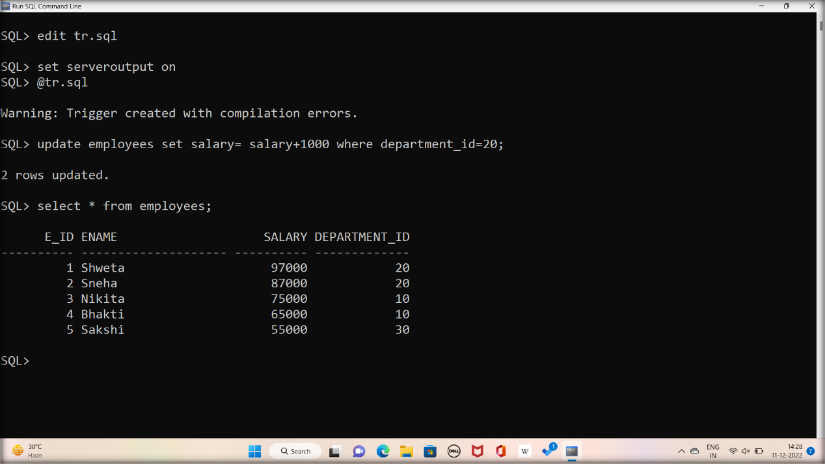

## Skill developed / Learning out of this Micro-Project:

* + You can call stored procedures and functions from inside a trigger.
  + You can use external code as a trigger by using CLR triggers. This type of trigger specifies the method of an assembly written in .NET to bind with the trigger.
  + You can use triggers to implement referential integrity across databases. Unfortunately, SQL Server doesn't allow the creation of constraints between objects on different databases, but by using triggers you can simulate the behavior of constraints.

## Applications of this Micro-Project:

By using a trigger you can keep track of the changes on a given table by writing a log record with information about the user that made the change and what was changed.